Solution and Answer Guide
Camm/Cochran/Fry/Ohlmann/Anderson/Sweeney/Williams, Essentials of Modern Business Statistics w/MS Excel 9th Edition, 9780357984505; Chapter 3: Descriptive Statistics: Numerical Measures
Table of Contents
Practice Problems 1

Practice Problems
1. eICU Waiting Time: There is a severe shortage of critical care doctors and nurses to provide intensive-care services in hospitals. To offset this shortage, many hospitals, such as Emory Hospital in Atlanta, are using electronic intensive-care units (eICUs) to help provide this care to patients (Emory University News Center). eICUs use electronic monitoring tools and two-way communication through video and audio so that a centralized staff of specially trained doctors and nurses—who can be located as far away as Australia—can provide critical care services to patients located in remote hospitals without fully staffed ICUs. One of the most important metrics tracked by these eICUs is the time that a patient must wait for the first video interaction between the patient and the eICU staff. Consider the following sample of 40 patient waiting times until their first video interaction with the eICU staff.
a. Compute the mean waiting time for these 40 patients.
b. Compare the median waiting time.
c. Compute the mode.
d. Compute the first and third quartiles.
Solution:
a. Compute the mean waiting time for these 40 patients.
Step 1. As outlined in the Appendix: Getting Started with R and RStudio, change the working directory to where the file eicu_r.csv is located
Step 2. To read the file and create a data frame, enter the following in the Console pane of RStudio:
eicu_df = read.csv("eicu_r.csv")
Step 3. A summary of the descriptive statistics for the Wait Time data is created by entering the command:
summary(eicu_df)
In this case, there is no need to create a vector for the variable Wait.Time since it is the only variable in the data frame.
The summary function produces the following output:
Wait.Time
Min.: 37.00 1st Qu.: 41.00 Median: 43.00 Mean: 43.83 3rd Qu.: 45.25 Max.: 61.00
The mean wait time is 43.83.
b. Compare the median waiting time. The median is 43.00, which is shown in the summary command output.
c. Compute the mode.
Step 4. The table command is applied to the data frame to find the mode. Enter the following command:
table(eicu_df)
Which produces the following result:
37 | 38 | 39 | 40 | 41 | 42 | 43 | 44 | 45 | 46 | 48 | 49 | 51 | 55 | 61
2 | 1 | 1 | 5 | 4 | 6 | 5 | 2 | 4 | 2 | 1 | 4 | 1 | 1 | 1
The most frequent wait time is 42 minutes, with 6 occurrences
d. Compute the first and third quartiles.
The data are available through the summary command. The first quartile is 41.0 minutes, while the 3rd quartile time is 45.25 minutes.
2. Round-Trip Flight Prices. The file fights_r.csv provides round-trip flight prices from 14 major U.S. cities to Atlanta and Salt Lake City.
a. Compute the mean price for a round-trip flight into Atlanta and the mean price for a round-trip flight into Salt Lake City. Is Atlanta less expensive to fly into than Salt Lake City? If so, what could explain this difference?
b. Compute the range, variance, and standard deviation for the two samples. What does this information tell you about the prices for flights into these two cities?
Solution
a. Compute the mean price for a round-trip flight into Atlanta and the mean price for a round-trip flight into Salt Lake City. Is Atlanta less expensive to fly into than Salt Lake City? If so, what could explain this difference?
Step 1. As outlined in the Appendix: Getting Started with R and RStudio, change the working directory to where the file flights_r.csv is located
Step 2. To read the file and create a data frame, enter the following in the Console pane of RStudio:
flights_df = read.csv("flights_r.csv")
Step 3. A summary of the descriptive statistics for the flights data is created by entering the command:
summary(flights_df)
This command creates the following output in the Console pane of RStudio.
Departure.City | Atlanta | Salt_Lake_City
Length: 14 | Min.: 249.6 | Min.: 159.6
Class: character | 1st Qu.: 312.6 | 1st Qu.: 301.1
Mode: character | Median: 339.9 | Median: 420.1
 | Mean: 356.7 | Mean: 400.9
 | 3rd Qu.: 378.4 | 3rd Qu.: 503.1
 | Max.: 539.6 | Max.: 618.4
The mean price for a round-trip flight into Atlanta is $356.7, and the mean price for a round-trip flight into Salt Lake City is $400.9. Atlanta is less expensive to fly into, which may be explained by it’s location relative to other major cities.
b. Compute the range, variance, and standard deviation for the two samples. What does this information tell you about the prices for flights into these two cities?
Step 4: The range, variance, and standard deviation for Atlanta can be found with the following commands.
range(flights_df$Atlanta)
sd(flights_df$Atlanta)
var(flights_df$Atlanta)
range(flights_df$Salt_Lake_City)
sd(flights_df$Salt_Lake_City)
var(flights_df$Salt_Lake_City)
These three commands create the following output for Atlanta.
[1] 249.6, 539.6
[1] 74.27926
[1] 5517.408
These three commands create the following output for Salt Lake City.
[1] 159.6, 618.4
[1] 137.5984
[1] 18933.32
For flights into Atlanta, the range is $290.00, the variance is 5,517.41, and the standard deviation is $74.28. For flights into Salt Lake City, the range is $458.80, the variance is 18933.32, and the standard deviation is $137.60. The prices for round-trip flights into Atlanta are less variable than prices for round-trip flights into Salt Lake City. This could also be explained by Atlanta’s relative nearness to the 14 departure cities.
3. Cell Phone Companies Customer Satisfaction. Consumer Reports provides overall customer satisfaction scores for AT&T, Sprint, T-Mobile, and Verizon cell phone services in major metropolitan areas throughout the United States. The rating for each service reflects overall customer satisfaction considering a variety of factors such as cost, connectivity problems, dropped calls, static interference, and customer support. A satisfaction scale from 0 to 100 is used with 0 indicating completely dissatisfied and 100 indicating completely satisfied. Suppose that the ratings for the four cell phone services in 20 metropolitan areas are given in the file cellservice_r.csv.
a. Consider T-Mobile first. What is the median rating?
b. Develop a five-number summary for the T-Mobile service.
c. Are there outliers for T-Mobile? Explain.
d. Repeat parts (b) and (c) for the other three cell phone services.
e. Show the boxplots for the four cell phone services on one graph. Discuss what a comparison of the boxplots tells about the four services. Which service do Consumer Reports recommend as being best in terms of overall customer satisfaction?
Solution
a. Consider T-Mobile first. What is the median rating?
Step 1. As outlined in the Appendix: Getting Started with R and RStudio, change the working directory to where the file cellservice_r.csv is located
Step 2. To read the file and create a data frame, enter the following in the Console pane of RStudio:
cell_df = read.csv("cellservice_r.csv")
Step 3. The exact variable names can be found by using the following command.
str(cell_df)
The command produces the following output in the Console pane of RStudio.
data.frame': 20 obs. of 5 variables:
$ City: chr "Atlanta" "Boston" "Chicago" "Dallas" ...
$ AT.T: int 70 69 71 75 71 73 73 72 66 68 ...
$ Sprint: int 66 64 65 65 67 65 64 68 65 69 ...
$ T.Mobile: int 71 74 70 74 73 77 75 74 68 73 ...
$ Verizon: int 79 76 77 78 77 79 81 81 78 80 ...
Step 4: The median value for T Mobile can be found using the summary command. Enter the following:
summary(cell_df$T.Mobile)
This command produces the following output in the Console pane of RStudio.
Min. 1st Qu. Median Mean 3rd Qu. Max.
68.00 71.75 73.50 73.15 74.25 77.00
The median for T-Mobile is 73.50.
b. Develop a five-number summary for the T-Mobile service.
Step 5. The five-number summary can be found using the following command.
fivenum(cell_df$T.M)
The command produces the following output:
[1] 68.0 71.5 73.5 74.5 77.0
c. Are there outliers for T-Mobile? Explain.
Step 6. One way to identify outliers is to graph the data. The following command produces line plots for all four cell service providers.(Parts b & c)
ylim=range(c(63,90))
plot(cell_df$T.Mobile,type="l", col="red",lwd="2",ylim=ylim,ylab="Satisfaction")
lines(cell_df$AT.T,lty="dashed",col="blue",lwd="2")
lines(cell_df$Sprint,lty="dotted", col="green",lwd=2)
lines(cell_df$Verizon,lty="dotdash", col="black",lwd=2)
legend("topleft",c("T-Mobile","AT&T","Sprint","Verizon"),col=c("red","blue","green","black"),lty=1:4)
The above commands create the following graph:
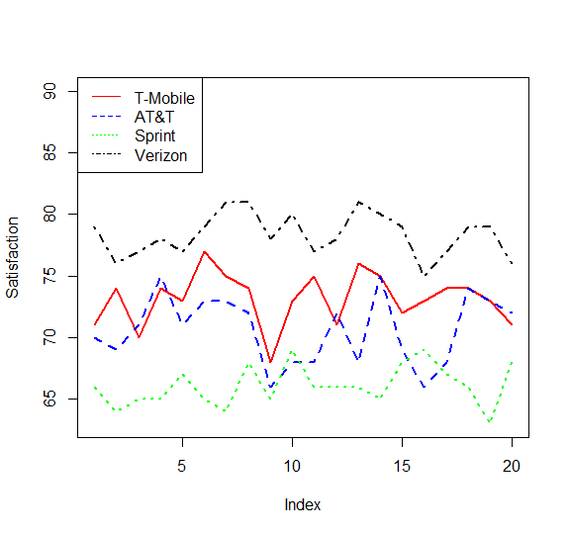
The data for one cell provider can be plotted using the plot command alone.
plot(cell_df$T.Mobile,type="l",col="red")
The command options include: type=”1”, producing a solid line, col=”red” producing a red line.
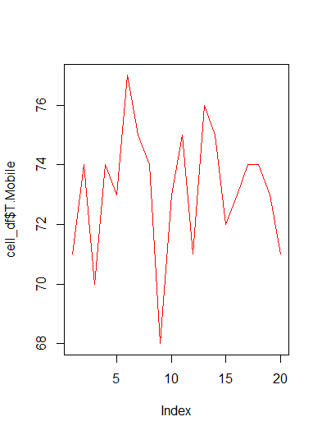
Each additional line command adds another line to the graph. For example, the command
lines(cell_df$AT.T,lty="dashed",col="blue",lwd="2")
adds AT&T to the graph using a different line type (lty=”dashed”), a different line color (col=”blue”) and line width(lwd=”2”).
A legend is added using the following command:
legend("topleft",c("T-Mobile","AT&T","Sprint","Verizon"),col=c("red","blue","green","black"),lty=1:4)
The graphs do not identify any outliers. Another method to identify outliers utilizes the interquartile range.
IQR = Q3 – Q₁ = 74.75 – 71.25 = 3.5
Lower limit = Q₁ – 1.5(IQR) = 71.25 – 1.5(3.5) = 66
Upper limit = Q₃ + 1.5(IQR) = 74.75 + 1.5(3.5) = 80
All ratings are between 66 and 80. There are no outliers for the T-Mobile service
d. Repeat parts (b) and (c) for the other three cell phone services.
Step 7. Enter the following commands to produce five number summaries for the remaining carriers.
fivenum(cell_df$AT.T)
fivenum(cell_df$Sprint)
fivenum(cell_df$Verizon)
The output produced is shown in the Console pane.
[1] 66 68 71 73 75
[1] 63.0 65.0 66.0 67.5 69.0
[1] 75.0 77.0 78.5 79.5 81.0
AT&T 66, 68, 71, 73, 75 Limits: 60.5 and 80.5
Sprint 63, 65, 66, 67.75, 69 Limits: 60.875 and 71.875
Verizon 75, 77, 78.5, 79.75, 81 Limits: 72.875 and 83.875
There are no outliers for any of the cell phone services.
e. Show the boxplots for the four cell phone services on one graph. Discuss what a comparison of the boxplots tells about the four services. Which service do Consumer Reports recommend as being best in terms of overall customer satisfaction?
Step 8. In order to create the comparative boxplots in one graph, a subset of the original data frame needs to be created with the City variable eliminated.
cell_adj_df = subset (cell_df, select = -City)
Step 9. Enter the following command to create a boxplot for all services on one chart.
boxplot(cell_adj_df)
The boxplot produced is shown below.
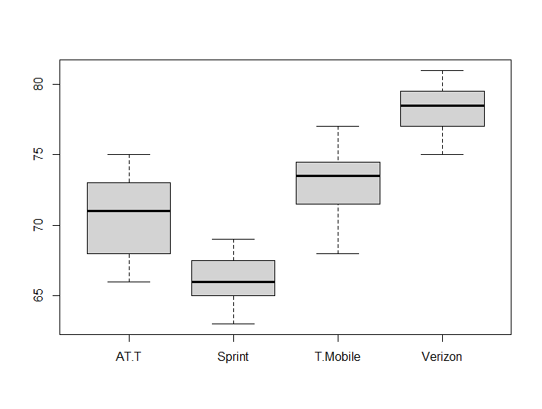
The box plots show that Verizon is the best cell phone service provider in terms of overall customer satisfaction. Verizon’s lowest rating is better than the highest AT&T and Sprint ratings and is better than 75% of the T-Mobile ratings. Sprint shows the lowest customer satisfaction ratings among the four services.
4. Smoke Detector Use and Death Rates. Over the past 40 years, the percentage of homes in the United States with smoke detectors has risen steadily and has plateaued at about 96% as of 2015 (National Fire Protection Association website). With this increase in the use of home smoke detectors, what has happened to the death rate from home fires? The file smokedetectors_r.csv contains 17 years of data on the estimated percentage of homes with smoke detectors and the estimated home fire deaths per million of the population.
a. Do you expect a positive or negative relationship between smoke detector use and deaths from home fires? Why or why not?
b. Compute and report the correlation coefficient. Is there a positive or negative correlation between smoke detector use and deaths from home fires? Comment.
c. Show a scatter plot of the death rate per million of the population and the percentage of homes with smoke detectors.
Solution:
a. Do you expect a positive or negative relationship between smoke detector use and deaths from home fires? Why or why not?
We would expect to see a negative relationship between smoke detector use and deaths from home fires—that is, as more households have smoke detectors, warning of fire would help inhabitants escape and lead to fewer deaths from home fires.
b. Compute and report the correlation coefficient. Is there a positive or negative correlation between smoke detector use and deaths from home fires? Comment.
Step 1. As outlined in the Appendix: Getting Started with R and RStudio, change the working directory to where the file smokedetectors_r.csv is located
Step 2. To read the file and create a data frame, enter the following in the Console pane of RStudio:
cell_df = read.csv("smokedetectors_r.csv")
Step 3. Run the str() command to determine the exact variable labels.
str(Smoke_df)
The following output appears in the Console pane.
data.frame': 17 obs. of 2 variables:
$ Homes.With: num 0.5 0.67 0.74 0.76 0.77 0.82 0.81 0.85 0.86 0.88 ...
$ Deaths.per.Mil: num 22.9 20.8 17.3 20.5 19.4 18.9 17.6 16.2 13.6 14.4 ...
The two variables in the data frame are labeled: Homes With and Deaths per Mil
To reference these variables in R use: Homes.With and Deaths.per.Mil. Spaces are replaced with a period, and capitalization must be followed.
Step 4. Create variable vectors.
detect=smoke_df$Homes.With
deaths=smoke_df$Deaths.per.Mil
Step 5. Calculate the covariance and correlation between the two variables by entering the following two commands in the Console pane.
cov(detect,deaths)
cor(detect,deaths)
The output produced is shown in the Console pane.
[1] -0.5146875
[1] -0.9059553
The value for covariance is -0.5146875 and the value for correlation is -0.9059553. There is a strong negative correlation between smoke detector use and deaths from home fires.
c. Show a scatter plot of the death rate per million of the population and the percentage of homes with smoke detectors.
Step 6. Run the plot() command to create a scatter plot.
plot(detect,deaths)
The following output appears in the plot pane of R Studio.
